**Face Recognition Attendance System Using Face Encoding Algorithm**

Manish Kumar , Yuvraj Singh , Mr. Ajay Shankar

**Abstract**— The "Face Recognition for Attendance" project in a Linux environment is a cutting-edge solution designed to revolutionize attendance management systems by harnessing the power of open-source tools and Linux-based technologies. Traditional attendance tracking methods often suffer from inaccuracies, inefficiencies, and a lack of security. This project leverages the robust capabilities of Linux to implement a secure, efficient, and scalable facial recognition attendance system.

[3] **RFID(Radio Frequency Identification)-based Attendance System:**

A number of works related to Radio Frequency Identification (RFID) based Attendance Systems exist in the literature. In the authors have proposed RFID based system in which students carry a RFID tag type ID card and they need to place that on the card reader to record their attendance. RS232 is used to connect the system to the computer and save the recorded attendance from the database. This system may give rise to the problem of fraudulent access. Unauthorized person may make use of authorized ID card and enter into the organization.

**[3] Fingerprint based Attendance System:**

In A portable fingerprint device has been developed which can be passed among the students to place their finger on the sensor during the lecture time without the instructor’s intervention. This system guarantees a fool proof method for marking the attendance. The problem with this approach is that passing of the device during the lecture time may distract the attention of the students.

**[3] Iris-Recognition Based Attendance System:**

Iris is another bio-metric that can be used for Attendance Systems. In authors have proposed Daugmans algorithm is based Iris recognition system. This system uses iris recognition management system that does capturing the image of iris recognition, extraction, storing and matching. But the difficulty occurs to lay the transmission lines in the places where the topography is bad. In authors have proposed a system based on real time face recognition which is reliable, secure and fast which needs improvement in different lighting conditions.

Keywords— Face Recognition, Attendance using MLFace Encoding Algorithm, Vector Gradient, Monitoring based on Face, Security, MSAI and Alert based security.

# I. **INTRODUCTION**

A Face Recognition Attendance System is a technology-driven solution designed to automate the process of tracking and recording attendance in various settings, such as schools, offices, and events, using facial recognition technology. This system relies on a Face Encoding Algorithm as one of its crucial components.

[1][2][3] Here's an introduction to the concept and components of a Face Recognition Attendance System, with a focus on the Face Encoding Algorithm:

1. Face Recognition Technology:

Face recognition is a biometric technology that identifies and verifies individuals by analysing and comparing their facial features. It's widely used for security, access control, and attendance tracking.

2. Attendance Automation:

Traditional attendance systems often involve manual processes, like taking roll calls, signing in on paper, or using card-based systems. A Face Recognition Attendance System streamlines this process by automating attendance tracking.

3. Components of the System:

- Face Detection: The system first detects and locates faces in images or video streams. It uses computer vision techniques to identify face regions.

- Face Encoding: This is a crucial component of the system. The Face Encoding Algorithm extracts unique features from each detected face, creating a numerical representation of the face that can be compared for recognition.

- Database: The system maintains a database of face encodings along with associated user information (e.g., names, IDs, roles).

- Recognition Engine: The recognition engine compares the face encodings of the detected faces with those in the database to determine if a match is found.

4. Face Encoding Algorithm:

- The Face Encoding Algorithm is a key aspect of the system. It transforms a person's facial features into a unique numerical representation, often referred to as a "face embedding" or "face signature."

- This encoding is based on deep learning techniques, usually employing Convolutional Neural Networks (CNNs) to extract features that are distinctive and robust to variations in lighting, pose, and facial expressions.

- Once the face is encoded, it can be compared to previously encoded faces stored in the database to determine if the person is recognized and their attendance is marked.

5. Benefits:

- Accuracy: Face recognition systems offer high accuracy in attendance tracking as they are less susceptible to fraudulent practices like buddy punching or proxy attendance.

- Efficiency: They automate the process, saving time and reducing the administrative burden.

- Security: Access to sensitive areas can be controlled through face recognition, enhancing security.

- Contactless: In a post-pandemic world, the contactless nature of this technology is advantageous.

6. Challenges:

- Privacy concerns: Storing and processing facial data must be done with utmost care to protect individuals' privacy.

- Technical limitations: Face recognition may not work well under poor lighting conditions or with low-resolution cameras.

Face Recognition Attendance Systems have become increasingly popular due to their effectiveness and convenience. However, they should be implemented with careful consideration of privacy and data security regulations. Additionally, the accuracy and performance of the Face Encoding Algorithm play a vital role in the success of the system.

II. **LITERATURE SURVEY AND RELEATED WORK**

2.1 Student Attendance Monitoring System Using Face Recognition by E CHARAN SAI, SHAIK ALTHAF HUSSAIN, SYED KHAJA, AMARA SHYAM: SSRN– [1] They used Haar-cascade model to detect faces and passed the cropped images from frame for processing. This method boosts the performance by analyzing only those images which are in ROI (Region of Interest)

2.2 Automated Attendance System using Machine Learning Approach– [2] In this paper Histogram of Oriented Gradient approach is used which boosted the processing speed and reduce the cpu throughput which is further assisted by changing images to greyscale and oriented gradient for reduced input data. This approach is by far the best method to increase speed but with the expanse of accuracy and augmentation in labeled images.

2.3Automated attendance system using face recognition A Jadhav, A Jadhav, T Ladhe -[3] RFID (Radio Frequency Identification)-based Attendance System A number of works related to [3]Radio Frequency Identification (RFID) based Attendance Systems exist in the literature. In [6] the authors have proposed RFID based system in which students carry a RFID tag type ID card and they need to place that on the card reader to record their attendance. RS232 is used to connect the system to the computer and save the recorded attendance from the database. This system may give rise to the problem of fraudulent access. Unauthorized person may make use of authorized ID card and enter into the organization

Fingerprint based Attendance System In [1] A portable fingerprint device has been developed which can be passed among the students to place their finger on the sensor during the lecture time without the instructor’s intervention. This system guarantees a foolproof method for marking the attendance. The problem with this approach is that passing of the device during the lecture time may distract the attention of the students.

**Primary Survey Data**

Problems identified:

• Lack of security in modern IOT based attendance, where any non-organizational person get mark attendance from ID Card, and have entry.

• Such problems can be logged in Linux environment and when unauthorized access is detected, respective authority is alerted.

• Use of Faster and efficient technologies for better performance.

* Eigenfaces (1991)
* Local Binary Patterns Histograms (LBPH) (1996)
* Fisherfaces (1997)
* Scale Invariant Feature Transform (SIFT) (1999)
* Speed Up Robust Features (SURF) (2006)

Each method follows a different approach to extracting and matching the image information with the input image. Fischer-faces and Eigenfaces have almost similar approaches as well as SURF and SIFT. LBPH is a simple yet very efficient method but is slow compared to modern face recognizers.

These algorithms are not faster compared to modern days face-recognition algorithms. Traditional algorithms can’t be trained only by taking a single picture of a person.

**Survey Results:**

The Survey is done to the public to get proper access to the results and the results are out.

We concluded the following insights from Literature Survey

* Accuracy over speed
* Speed fater compared to traditional system
* No issue during data transmission
* Encryption and data backup
* Monitoring and logging
* Link: <https://github.com/Sah-Manish/>

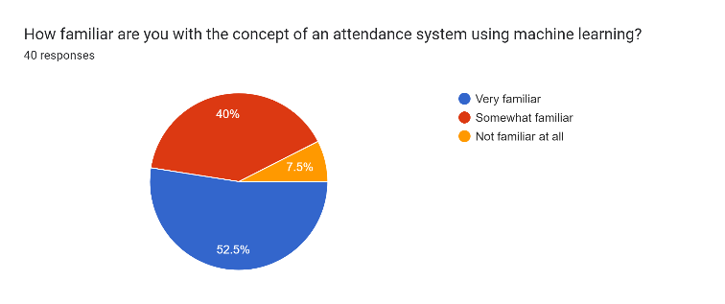

Forms response chart. Question title: Have you ever used an attendance system that employs machine learning technology?
. Number of responses: 40 responses.

Forms response chart. Question title: Do you believe that using machine learning for attendance tracking is a more efficient method than traditional methods (e.g., paper-based, manual entry)?
. Number of responses: 40 responses.

Forms response chart. Question title: Please rate the efficiency of traditional attendance tracking methods (e.g., paper-based, manual entry) on a scale from 1 to 10, with 1 being highly inefficient and 10 being highly efficient.
. Number of responses: 40 responses.

Forms response chart. Question title: In your opinion, how accurate are traditional attendance tracking methods (e.g., paper-based, manual entry) on a scale from 1 to 10, with 1 being highly inefficient and 10 being highly efficient.
. Number of responses: 40 responses.

Forms response chart. Question title: How likely are you to trust attendance data generated by machine learning-based systems?
. Number of responses: 40 responses.

Forms response chart. Question title: On a scale of 1 to 5, how concerned are you about the privacy and security of your attendance data when using machine learning-based systems?
. Number of responses: 40 responses.

Forms response chart. Question title: How effective do you think machine learning-based attendance systems are at reducing errors compared to old method in attendance tracking? Rate on a scale of 1 to 5, with 1 being not effective at all and 5 being highly effective.
. Number of responses: 40 responses.

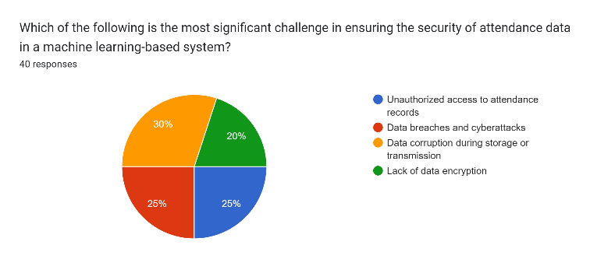

Forms response chart. Question title: In your opinion, what would be the most effective way to address the challenges associated with machine learning-based attendance systems?
. Number of responses: 40 responses.

Forms response chart. Question title: How often do you encounter issues with false positives (incorrectly marked as present) or false negatives (incorrectly marked as absent) in the attendance system? [your work place/college/university attendance system]
. Number of responses: 40 responses.

Forms response chart. Question title: What features or improvements would you rate more importance to enhance your experience with the attendance system?
. Number of responses: 40 responses.

Forms response chart. Question title: How willing are you to adapt to new attendance tracking technologies, including those based on machine learning?
. Number of responses: 40 responses.

Forms response chart. Question title: Would you be comfortable with your attendance being tracked using machine learning if it improved efficiency and accuracy? It depends (please specify conditions in others field)
. Number of responses: 40 responses.

Forms response chart. Question title: In your opinion, should machine learning attendance systems be used in educational institutions, workplaces, or both?
. Number of responses: 40 responses.

Forms response chart. Question title: How important is data privacy and security in the context of using machine learning for attendance tracking?
. Number of responses: 40 responses.

## **III. METHODOLOGY**

Latest Work with algorithm Explanation and result in simulation

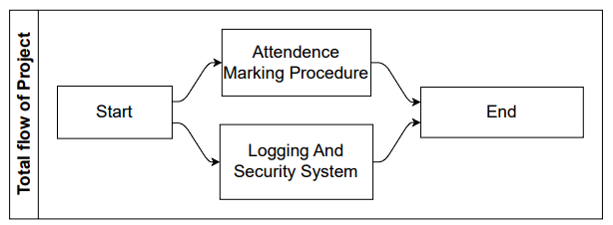

Our Project starts with simultaneously starting 2 services and have working together for better efficiency.

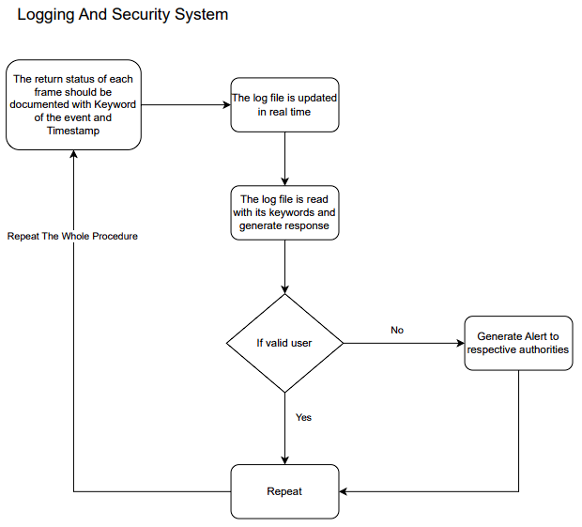

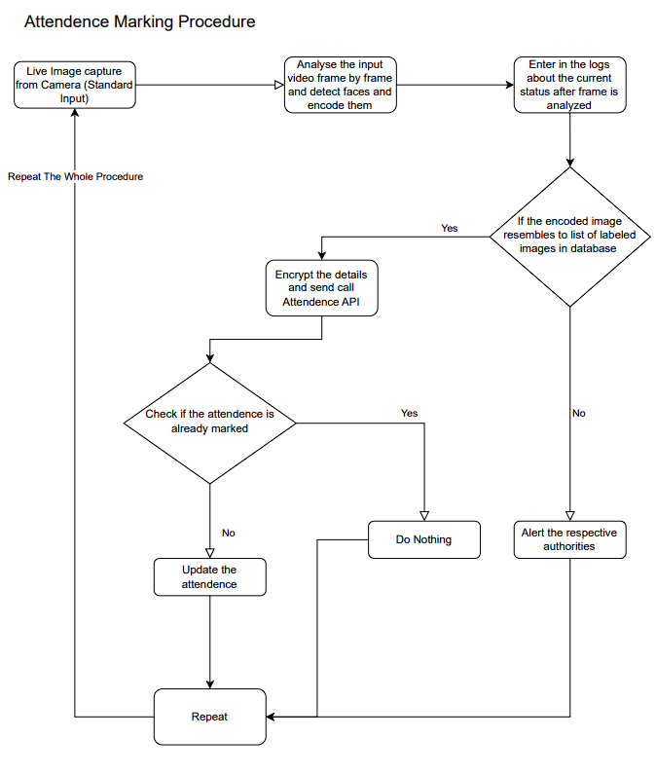

### IV. **CONCLUSION AND FUTURE SCOPE**

**Challenges Faced**

Although building facial recognition seems easy, it is not as easy in real-world images that are being taken without any constraints. There are several challenges that are faced by the Facial Recognitions System, as follows:

Illumination: It changes the face’s appearance drastically. It is observed that even slight changes in lighting conditions cause a significant impact on its results.

Pose: Facial Recognition systems are highly sensitive to the pose, Which may result in faulty recognition or no recognition if the database is only trained on frontal face view.

Facial Expressions: Different expressions of the same individual are another significant factor that needs to be taken into account. Modern Recognizers can easily deal with it, though.

Low Resolution: The recognizer must be trained on a good-resolution picture. Otherwise, the model will fail to extract features.

Aging: With increasing age, the human face features shape, lines, and texture changes which are yet another challenge.

**Conclusion:**

Face recognition technology can be used to build practical systems for attendance tracking, security access control, and more.

The face recognition system can be built using Python programming language and popular libraries such as OpenCV and face recognition.

Once the face recognition model is built, it can be integrated with an attendance system using Python programming and database management tools.

**Future work:**

One-one Matching can be replaced by multiple faces detection at once.

# **REFERENCE**

1. [1] SAI, E CHARAN and HUSSAIN, SHAIK ALTHAF and KHAJA, SYED and SHYAM, AMARA, Student Attendance Monitoring System Using Face Recognition (May 22, 2021). Available at SSRN: https://ssrn.com/abstract=3851056 or <http://dx.doi.org/10.2139/ssrn.3851056>
2. [2] H. Rathod, Y. Ware, S. Sane, S. Raulo, V. Pakhare and I. A. Rizvi, "Automated attendance system using machine learning approach," 2017 International Conference on Nascent Technologies in Engineering (ICNTE), Vashi, India, 2017, pp. 1-5, doi: 10.1109/ICNTE.2017.7947889.